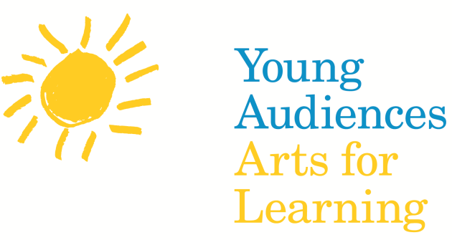 (Keep this or add your logo)

For Immediate Release

US House Resolution Designates March 16-22 As National Young Audiences Arts for Learning Week

Add in a second headline relating to your programs/events:
Throughout the US the National Young Audiences Arts for Learning Affiliate Network will Host More Than 500 Related Events and Programs During This Week

New York, NY (February 17, 2014, 10 a.m. EST) New dateline— Congresswoman Slaughter has introduced a Resolution to the House of Representatives designating the week of March 16-22, 2014 as National Young Audiences Arts for Learning Week. This week will honor the contributions Young Audiences Arts for Learning (YA) has made to schools nationwide through its arts-in-education programs and to encourage Americans to recognize the important contribution the arts make to society.

The House resolution, introduced by Representative Louise Slaughter (D-NY 25th District) co-chair of the Congressional Arts Caucus states “arts education, comprising a rich array of disciplines… is a core academic subject and an essential element of a complete and balanced education for all students”. The House resolution also emphasizes that “arts education enables students to develop critical thinking and problem solving skills… which supports academic success nationwide as well as personal growth outside the classroom.”

National Young Audiences Arts for Learning Week will be observed across the country by Young Audiences affiliates with special events, school activities, long-term residencies and performances to promote awareness for YA’s arts-in-education programs. It is estimated that more than 34,000 students will be participating in a Young Audiences Arts for Learning program during this week.

Founded in 1952, Young Audiences Arts for Learning is the nation’s leading source of arts in education services. YA’s mission is to inspire young people and expand their learning through the arts. Our network of 30 affiliates with 4,400 teaching artists reached almost five million children in 9,000 schools and community centers with 84,000 programs, such as arts-integrated workshops and residencies and professional learning opportunities for educators and artists.

For detailed information, please see links (e-blast) below:

House Resolution

Participating National Young Audiences Affiliates (link to YA Week webpage that lists all participating affiliates)

(Add in your affiliate boilerplate Information)
Young Audiences Arts for Learning, founded in 1952, is the nation’s leading source of arts-in-education services. YA’s mission is to inspire young people and expand their learning through the arts. This year, our network of 30 affiliates with 5,000 teaching artists reached 5 million children in over 6,000 schools and community centers with 85,000 performance demonstrations, workshops and teacher services.

###

Press Contact: (correct the press contact information)
Marcus Romero
T: (212) 860-1563 X108, E: marcus@ya.org
www.youngaudiences.org

